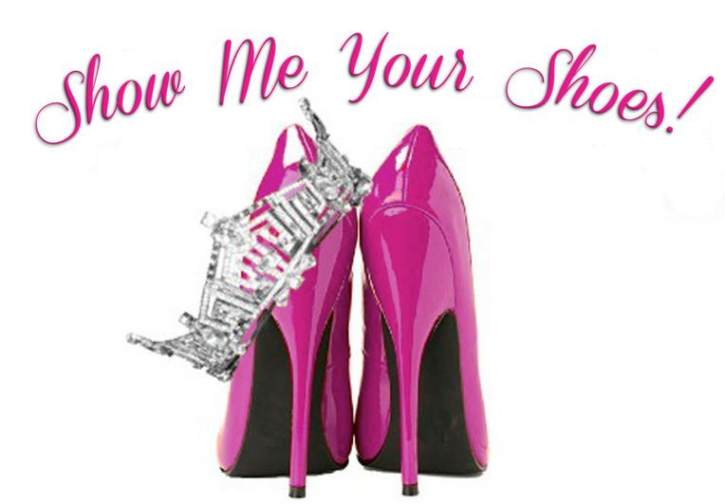

The “Show me your Shoes Parade” is a tradition in the Miss America Organization and is implemented in local and state pageants. At Miss Utah, contestants show off shoes and costumes that represent their county or platform. Previous Miss Carbon County winners have represented coal miners, international days, outdoors/hunting, Carbon Dinos, Helper Merchant baseball team, and the dinosaur museum. Awards and gifts are given. This is a great kick off to Miss Utah week and allows each contestant to show county pride.

At Miss Carbon County the “Show me your Shoes” is connected with the people’s choice award during the pageant. These shoes are not just everyday footwear.
- Each contestant will bring a pair of shoes that represents them and/or their interests.
- Be creative, add a splash of color or some bedazzles. Bring shoes that mean something to you. Encouraged to not spend over $10.00.
- The shoes will be displayed during the pageant in the lobby and the audience will vote for their favorite. Each vote is $1.00. The donations will go towards the next Miss Carbon County’s $250 Children’s Miracle Network donation for the Miss Utah Pageant.

This allows the audience to know a little bit more about each girl as they wait for the excitement to start and to support a good cause. The winner of the most votes will receive a special award sponsored by Dr. Justesen.

Cut off and hand in the information below with all other paperwork. Bring your shoes pageant day and take them home after the pageant with your display picture.
- - - - - - - - - - - - - - - - - - - - - - - - - - - - - - - - - - - - - - - - - - - - - - - - - - - - - - - - - - - - - - - - - - - - - -

Contestant Name: _____________________________________ Contestant Number:______

Please describe below the shows you are bringing and why they are significant to you, or how they represent you.
______________________________________________________________________________ ______________________________________________________________________________ ______________________________________________________________________________
____________________________________________________________________________________________________________________________________________________________
______________________________________________________________________________

